1. To display the name and department number of employee with number 7566.

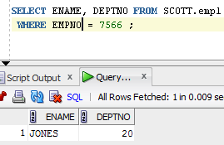

1. To display the name and department number of all employees in departments 10 and 30 in alphabetical order by name.

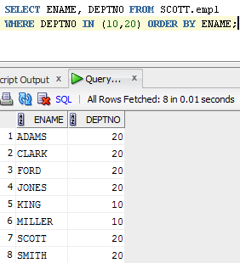

1. To display the name, department number and hire date of all employees who were hired in *1982*.

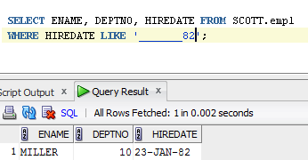

1. To display the name of all employees who have two consecutive Ls in their name and are in department 30 or their manager is 7782.

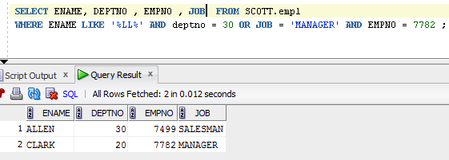

1. To display the name of all clerks of department 10 and 20 hired before 1983 .

 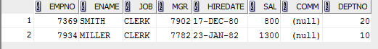

1. Display the name and salary for all employees whose salary is not in range of $1500 and $2850

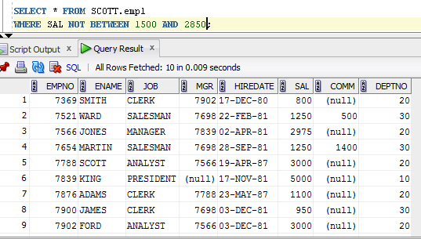

1. Display the name, salary and commission for all employees whose commission amount in greater than their salary increased by 10%.

